Mobile Apps for Google Android – Summer 2014

Group 1: Nailane Oliveira, Oliver Zavala, Chris Hoyek and Maxwell Carter

Quiz 4 – 06/19/2014

**Aquarium app – Marvin Wilbert**

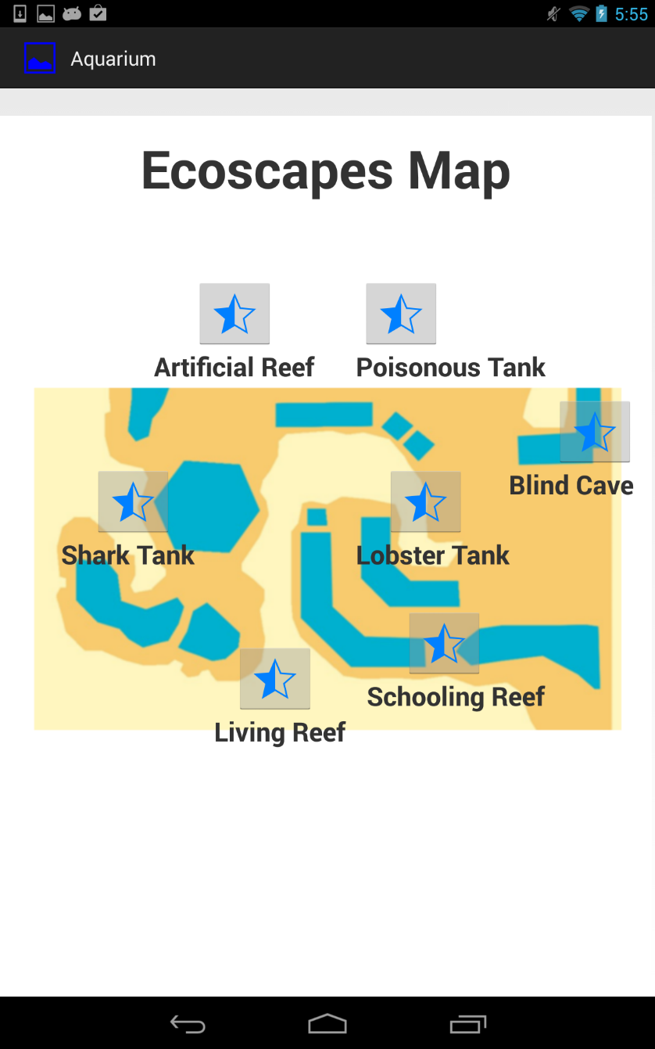

In the main menu, the user can tap the star and see information about the animals from the aquarium. In Eclipse, we can see the main menu in the source file inside the package “edu.fau.group6.ecoscapes.aquarium”. Each item has your own class that says what to do after the user tapped the star.

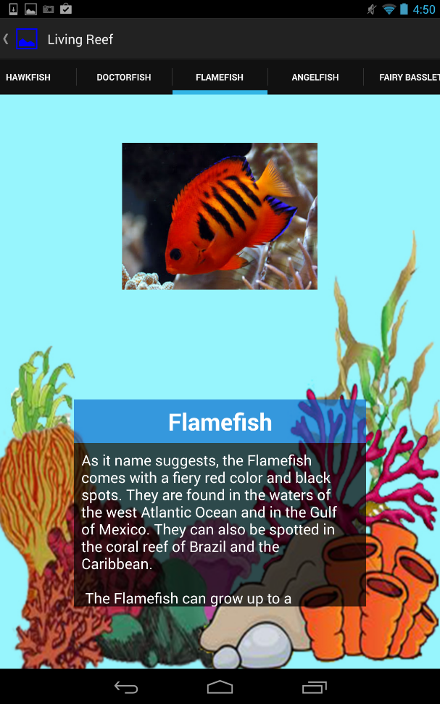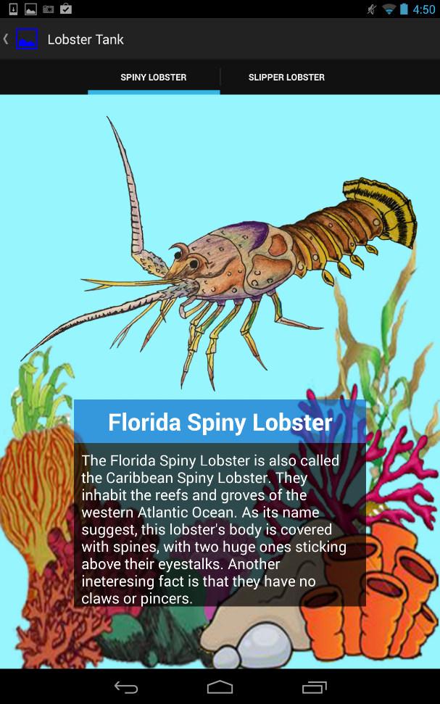

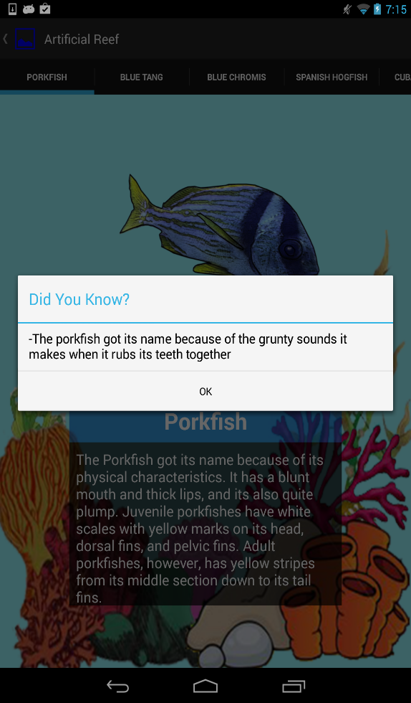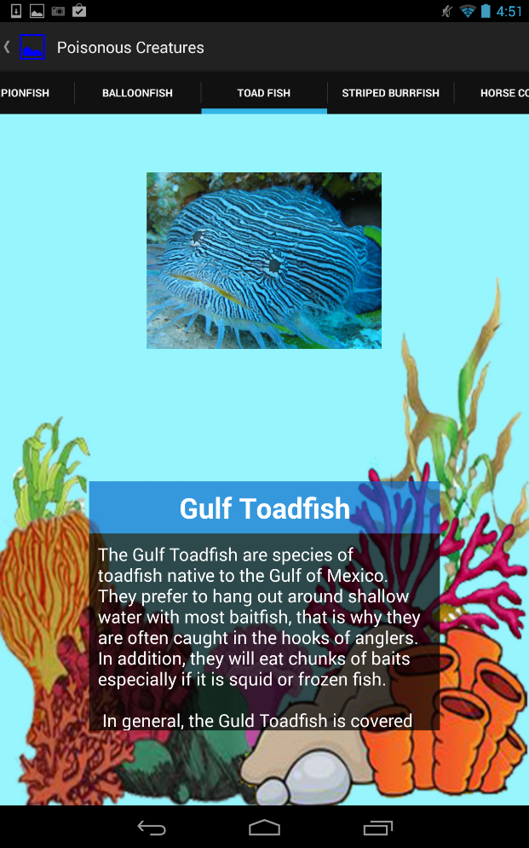

These are some examples of the information that is showed to the user. There is one menu on the top, so we can switch between the animals. These sections are organized in linear layout and the user is able to scroll the text. If the user tap the screen outside the text box, it appears “Did you know?” as the image above.

**Bugs App – Mike Ethan**

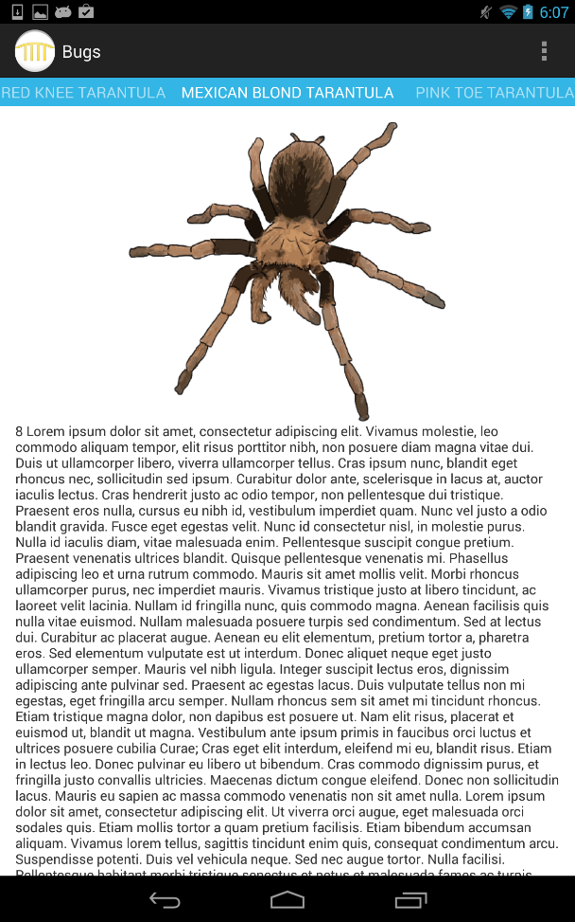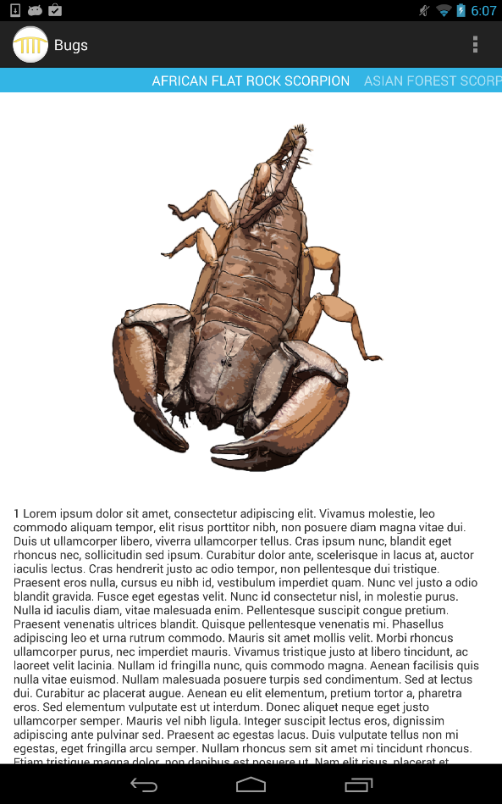

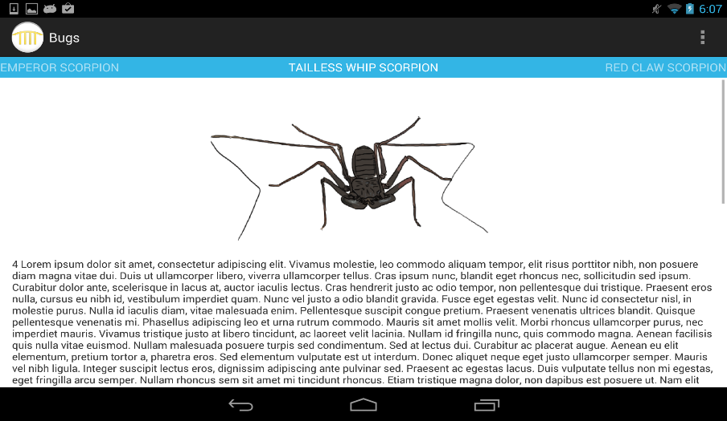

This app shows information about some bugs and it is possible switch between these animals with the menu on the top. In Eclipse, we can see in the source file two classes: BugsReceiver.java and MainActivity.java. These classes says the program what to do when the user switch the menu.

**Distance measurement – Julien Le Mellec**

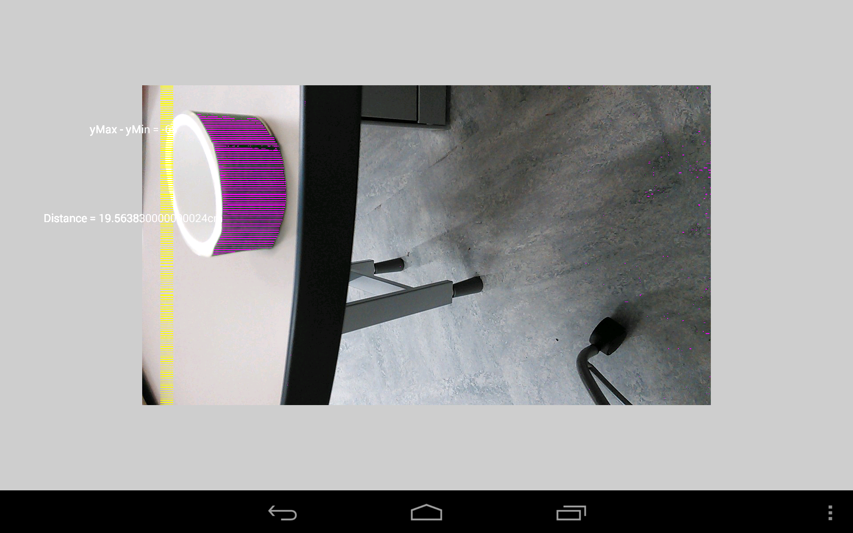

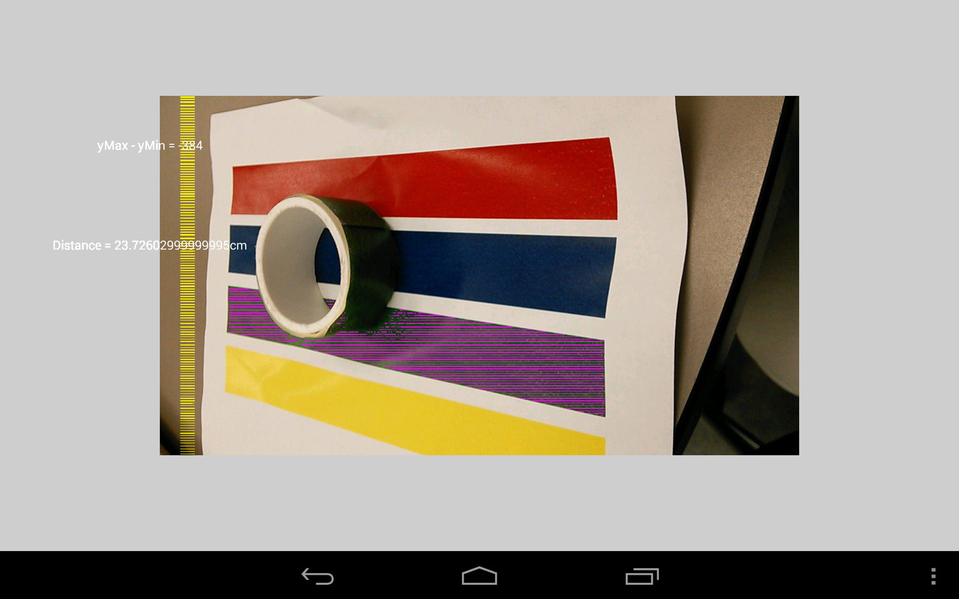

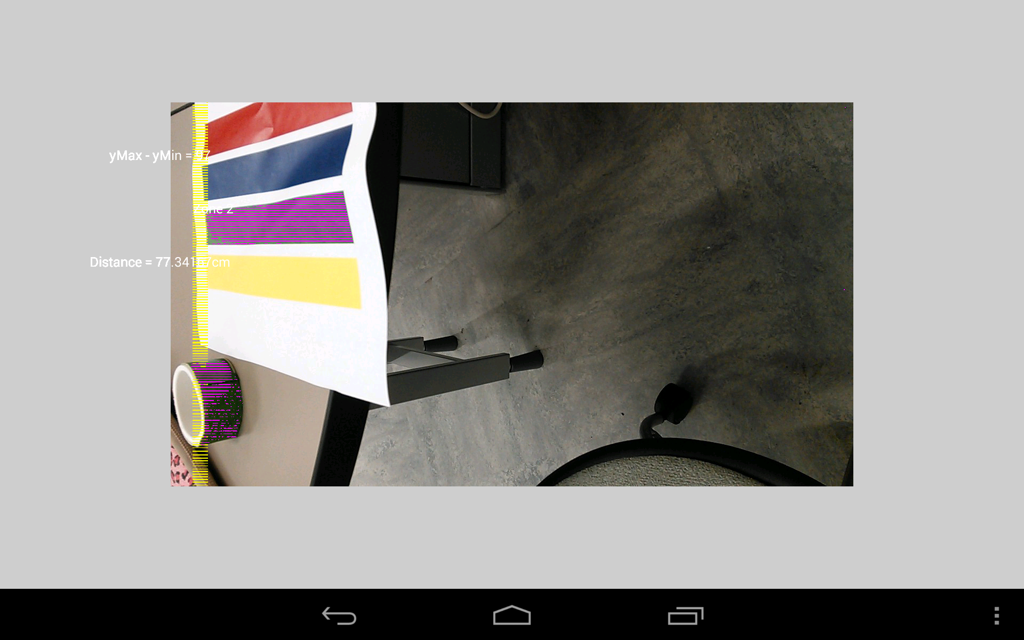

The purpose of this app is to estimate the distance with the camera sensor. The program recognize green objects as we can see in the images above. It is interesting that when the camera is closer to the objects, the distance is smaller. If we go far away with the camera, the distance increases. In this case, the source file has just the main program DetectRobot.java that has another Processing version in the same folder.